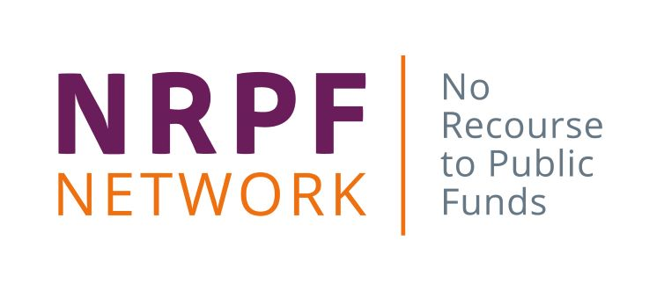
Booking form – online courses
Online course | Date | Cost
Select a course | Enter date | Price
Select a course | Enter date | Price
Delegate details

Delegate name |  | Job title | Email | Telephone
1 | Enter name | Enter job title | Enter email address | Enter number
2 | Enter name | Enter job title | Enter email address | Enter number
3 | Enter name | Enter job title | Enter email address | Enter number
4 | Enter name | Enter job title | Enter email address | Enter number
5 | Enter name | Enter job title | Enter email address | Enter number
6 | Enter name | Enter job title | Enter email address | Enter number
Method of payment

Please select one method of payment:
☐ I will pay £ enter total amount by debit or credit card
You will be sent a reference number by email with details of how to make the payment online. Your booking will only be confirmed and details of how to join will be provided once we have receipt of your payment.

☐ Please invoice my organisation for £ enter total amount
Please complete the invoice details below. Please note that your booking will not be confirmed until purchase order is provided. Islington Council is the supplier name.

Invoice details
Name | Enter name to send invoice to
Organisation | Enter organisation
Department | Enter department
Address | Enter address
Telephone | Enter number
Email | Enter email
Purchase order number | Enter number
Confirmation

Please tick to confirm you have read the terms and conditions ☐
Please email this form to: nrpf@islington.gov.uk. You will be contacted within five working days. We may need to request further information before confirming your place if this form is incomplete.
-------
No Recourse to Public Funds (NRPF) Network
Islington Council, 222 Upper Street, London N1 1XR
T: 020 7527 4878/6170 E: nrpf@islington.gov.uk
www.nrpfnetwork.org.uk

